Working Creating and Working with Batch files for SiteTools.

A step-by-step set of procedures has been created to help you generate site index summaries. The menu is laid out in the order which you will work, from raw files to finished product.
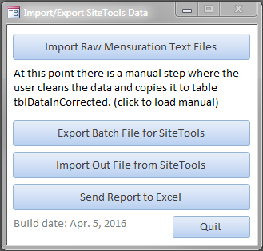
  - Tables included in this database
tblDataFromSiteTools – this table contains the data that SiteTools output
tblDataIn – contains the data from the raw mensuration files
tblDataInCorrected – there will be errors in the tblDataIn table that need to be corrected. Put your clean data in this table
tblSiteData – this data came from BECMaster28Feb2013_Env and can be changed by the user. The link to the site index data is the field PlotNumber
tblStandAge – is generated for you by a function in the program
tblTableNames – is a list of tables kept for documenting the data imported. It has no active roll in generating output
  - Importing raw mensuration text files
Clean files that follow a set format will produce nice clean data. It is best to take the time now to clean your raw data files to the following specifications:
FIZ: 1 to 2
Plot number: 3 to 9
Mensuration ID: 10 to 16
BAF: 17 to 18
Height: 19 to 21
Species: 22 to 23
DBH: 24 to 27
Tree condition: 28
Pathology 1: 29
Pathology 2: 30
Pathology 3: 31
Pathology 4: 32
Pathology 5: 33
Pathology 6: 34
Pathology 7: 35
Columns 19 to 34 are repeated 4 times across the line. i.e. 36 to 53.
Age: 87 to 90.

  - Cleaning up your imported data
You’re probably not going to catch all the errors in editing the raw files. The data imported from the raw mensuration text files will have errors ranging from misaligned fields to unknown species codes. It is your job to review and correct this data, ensuring that the data is accurate and recognizable by SiteTools. SiteTools is flexible with regards to column start and end specifications, also species lists are customizable in SiteTools. Be careful when working with species codes because these codes determine the site index curves that will be applied to your data. Copy your clean data to the table aptly named “tblDataInCorrected”.

  - Exporting a batch file to SiteTools
You should now be ready to export your data in a format palatable for SiteTools. Clicking the button will produce a little dialog box stating the format of the file to be exported to the batch file. The index will be automatically generated for you. The BH age is the maximum age found in the plot. Only records that contain species, age and height data will be included in the export.
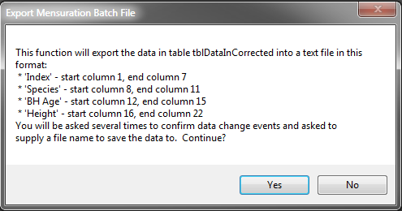

  - Using your batch file in SiteTools
Opening SiteTools (btools.exe) and clicking New in the file menu will get you started. In this first form you will enter the name of the input file you created in the previous step. It is important at this stage not to enter the location of the site index.
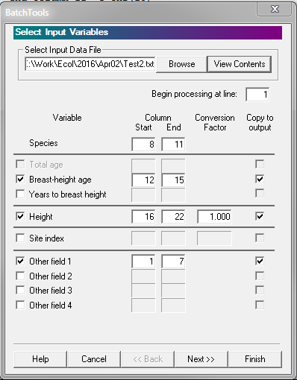

After clicking the Next button, you will get the output form. This is the form where you’ll enter the site index location. Don’t forget to enter the location and name of the output file.
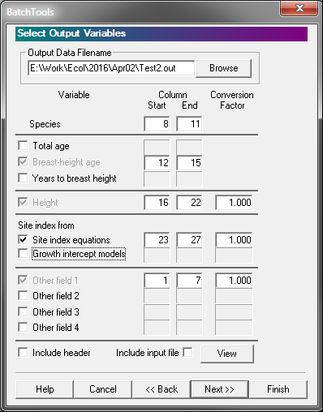
Clicking the Finish button will complete your work in SiteTools.

  - Importing the output from SiteTools
You will again be reminded of what is going to happen. It is important to note that any previous import from SiteTools will be deleted and replaced with the import.
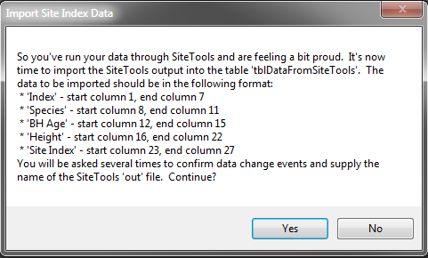
  - Sending your data to Excel
Okay, you’ve stuck with it for these past steps and are dying to see the results. Go ahead, click that button.
